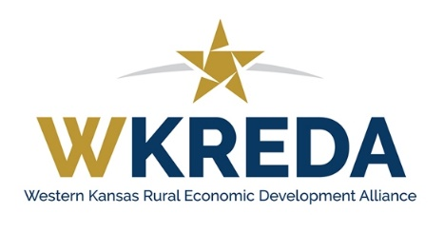

Quarterly Meeting Agenda
September 2-3, 2026
Liberal, Kansas

Wednesday, September 2, 2026

CD-101
Location: Randall Girl Scout Building
1100 N Kansas Avenue, Liberal, KS

Hotel: Comfort Inn & Suites ($135) 2891 Centennial Blvd., Liberal
Fairfield Inn & Suites ($114) 501 Hotel Drive, Liberal
Book your group rate for WKREDA Group
WKREDA room blocks close on August 24.

1:00 – 1:15 pm Welcome & Introductions
Eli Svaty, Executive Director, Seward County Development Corporation

1:15 – 2:15 PM Economic Development Strategic Planning
Kerissa Payne, Northwest Kansas Planning & Development (Invited)
Rachel Steiner, Friends University (Invited)
Cathy Domsch, Domsch Enterprises, Inc. (Invited)

2:15 – 2:45 pm Strategic Planning Sharing Session

2:45 – 3:00 pm Break

3:00 –3:45 pm Leveraging Artificial Intelligence for Economic Developers
Raquel Arellano, Business Performance Analysis Tool

3:45 – 4:00 PM Break

4:00 – 5:00 PM Artificial Intelligence Workshop
Bring your laptop for this interactive, hands-on session. Members are encouraged to share the AI tools they leverage to support economic development efforts. Prepare to share the tool, how you use it in economic development, and the approximate cost.

5:00 – 6:00 pm Break: Hotel Check In

6:00-8:30 pm Dinner
Billy’s Ayr Lanes, 2050 N Kansas Avenue
Enjoy dinner, drinks, arcade, bowling, and great company!

Thursday, September 3, 2026
Location: Randall Girl Scout Building
1100 N Kansas Avenue, Liberal, KS

8:00 – 8:30 am Light Breakfast

8:30 – 8:45 AM Welcome & Introductions

8:45 – 9:45 am WKREDA Business Meeting

9:45 – 10:00 am Break

10:00-11:30 pm Legislative Panel

11:30 – Noon: Resource Partner Updates

*No lunch provided.
**No virtual option for the business meeting.

